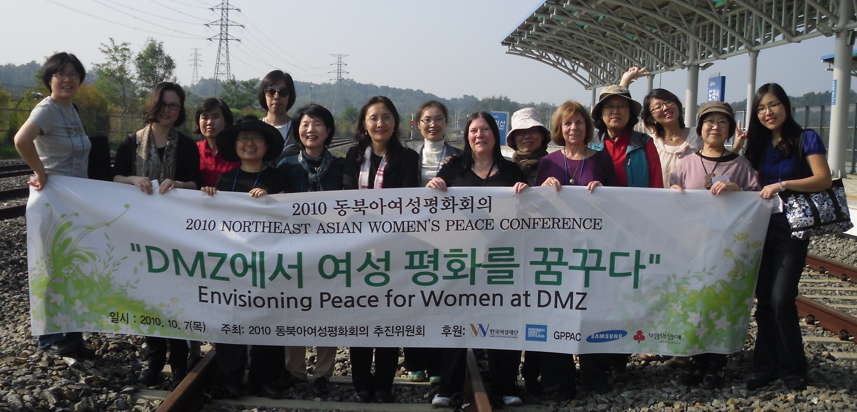

Taking the Women's Road to Peace on the Korean Peninsula:
A Report on the Northeast Asia Women's Peace Conference
October 2010 Seoul, Korea

Dialogue and Action Plan Formulation
Following presentation of the recommendations that emerged from the meeting of delegates to the Third Northeast Asia Women’s Peace Conference, and an update on the current situation on the Korean Peninsula, attendees will identify priorities, craft an action plan, and promote implementation of the recommendations.

Date: December 1, 2010
Time: 10:00 AM -2:00 PM
Place: Lindner Family Commons, 6th Floor, 1957 E St, NW, Washington, DC 20052
RSVP: by November 29, 2010 to pisa@gwu.edu ( a light lunch will be served)

AGENDA

10:00 AMWelcome Remarks, Linda J. Yarr, PISA
10:10-10:45The Current Situation in Northeast Asia, Dr. Hazel Smith, Professor and Head, Resilience Centre, Cranfield University
10:45-11:00Presentation of the Recommendations of the 2010 NEAWPC,
Narae Lee, International Coordinator, Peace Boat US
11:00-11:15Full Group Discussion to Identify Three Priority Recommendations
11:15-12:15Division into Small Working Groups to:
Outline next steps to implement recommendations
Identify role of a Women’s Council for the Six-Party Talks
Propose format, audience outreach and mode of publicity for a public event
12:15-12:45Reports of Working Group to Full Assembly
12:45- 2:00Lunch and Talk, “Women’s Roles in Peace Processes,” Jolynn Shoemaker, Executive Director, Women in International Security (WIIS)

Partnerships for International
Strategies in Asia
(PISA)
and
Peace Boat US
cordially invite you to

