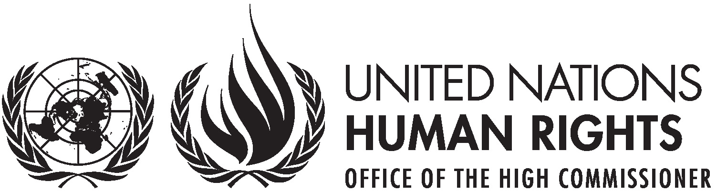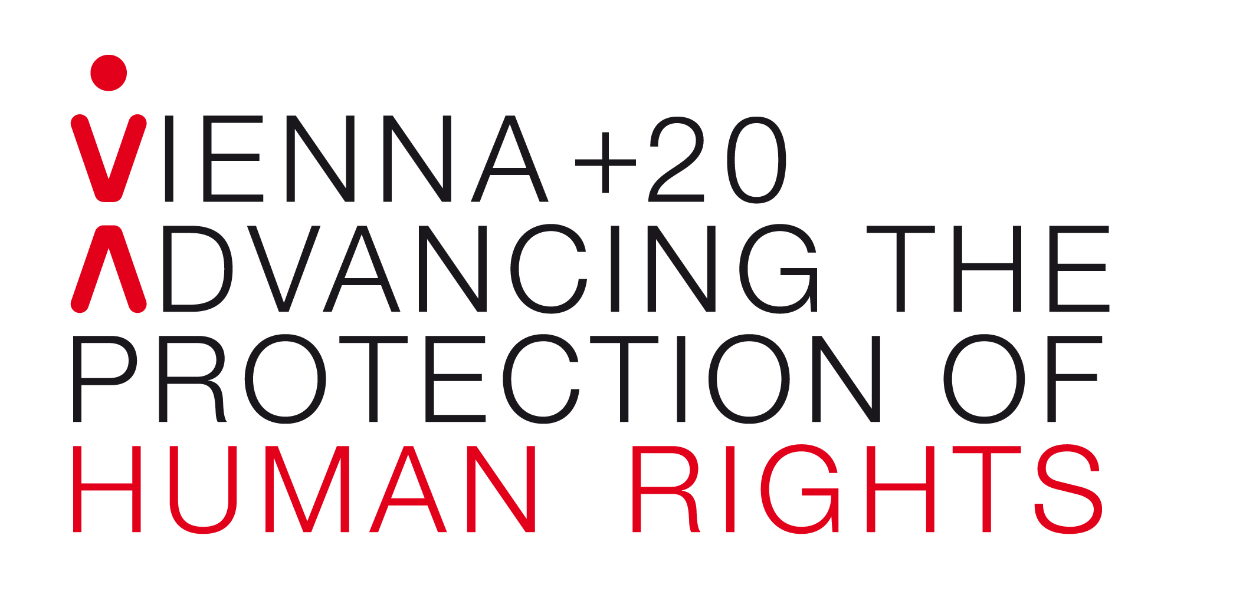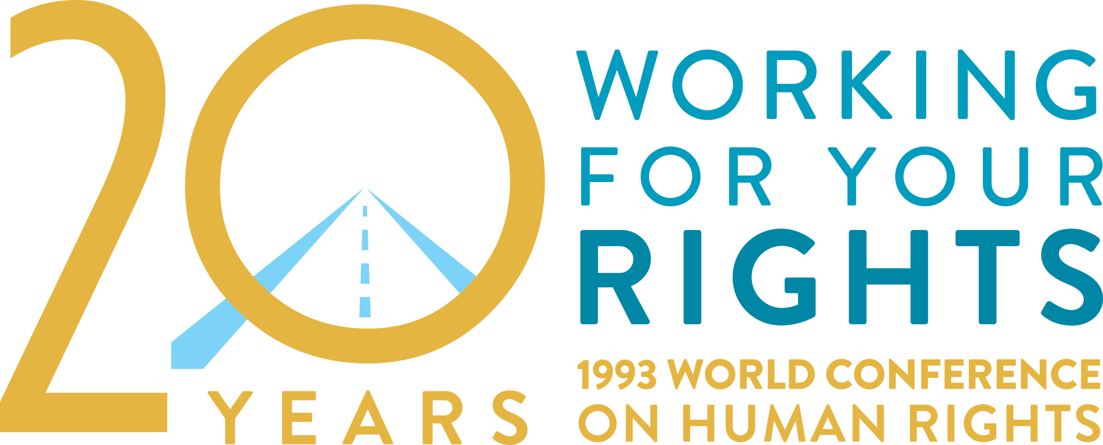

**Vienna+20**

**Human rights achievements, shortcomings and the way forward**

**High-level side event at the 68th Session of the United Nations General Assembly**

**Wednesday, 25 September 2013, 1:15-2:45pm, ECOSOC Chamber (CB),   
United Nations Headquarters, New York**

**Key note addresses by:**

Mr. **Ban Ki-moon**, United Nations Secretary-General (tbc); Ms. **Navi Pillay**, United Nations High Commissioner for Human Rights; H.E. Dr. **Heinz Fischer**, Federal President of the Republic of Austria

**Panel discussion**

* Ms. **Mary Robinson**, Special Envoy of the UN Secretary-General for the Great Lakes Region and former United Nations High Commissioner for Human Rights (1997-2002)
* Ms. **Louise Arbour**, President and CEO of the International Crisis Group and former United Nations High Commissioner for Human Rights (2004-2008)
* Moderator: Mr. **Ivan Šimonović**, Assistant Secretary-General for Human Rights

**Background**This year marks the 20th anniversary of the adoption of the Vienna Declaration and Programme of Action (VDPA) by the World Conference on Human Rights in June 1993 in Vienna, Austria. To strengthen, harmonise and coordinate the human rights work of the United Nations, the VDPA called for the establishment of the Office of the High Commissioner for Human Rights. In December that year, the General Assembly adopted resolution 48/141, designating the High Commissioner as the UN official with principal responsibility for human rights activities.

The 20th anniversary provides an opportunity to celebrate progress over the last 20 years and to identify challenges and solutions to fully implement the commitments made in Vienna. Positively, the United Nations now integrates a human rights perspective across all its work – from threats to international peace and security to the Millennium Development Goals and climate change. However, the past 20 years have also seen the deaths of millions of people in violation of their rights in the context of armed conflicts, and serious obstacles to the realization of economic, social and cultural rights of a large proportion of the world’s population. The tremendous urgency for strengthening international human rights action cannot be over-stated.

In June 2013, the Vienna+20 High-Level Expert Conference examined the legacy of the original conference and made recommendations to address challenges for further improvement in the protection and promotion of human rights. This second event in New York will provide a platform for high-level Government officials from around the world to look at institutional and political obstacles to progress and set out a vision for the future.

**For further information and to RSVP please contact:**

Nenad Vasić, OHCHR New York Office, 212 963 5998, or [vasic@un.org](mailto:vasic@un.org)