Jane Addams Children's Book Award
6oth Annual Award Ceremony

October 18, 2013 • 2:30pm • 777 United Nations Plaza FL 2 (44th & 1st) NYC
Join us for a memorable afternoon of award presentation and responses by authors and illustrators. Come meet and talk with the honored guests, including Award winners and honorees. Enjoy a reception and an opportunity for book signing after formal presentation of the awards. All the award books will be available for purchase. This event is free and open to all. Reservations are not needed. Please come and enjoy!

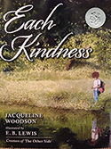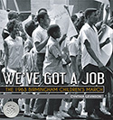
2013 Award Winners
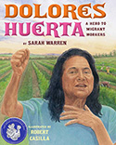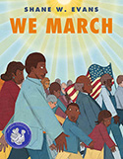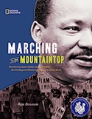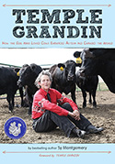
2013 Honor Books

This year the ceremony also celebrates the publication of The Jane Addams Children’s Book Award: Honoring Children’s Literature for Peace and Social Justice since 1953 (Scarecrow Press, 2013), a book about the Addams Award written for teachers, librarians and scholars.

