
a project of the Women's International League for Peace and Freedom (WILPF)
A Guide to PeaceWomen.org
an online hub and portal of information, resources, news and events on Women, Peace and Security and SCR 1325.

PeaceWomen is a Project of WILPF, an international women’s peace organization with national sections and members around the world. The PeaceWomen Project monitors, informs, and advocates for the rapid and full implementation of the UN Security Council Resolutions on Women, Peace and Security (Resolutions 1325, 1820, 1888, 1889 and 1960). PeaceWomen promotes the role of women in preventing conflict, and the equal and full participation of women in all efforts to create and maintain peace and human security.

PeaceWomen provides a comprehensive online information source on Women, Peace and Security.
PeaceWomen.org main sections:
I. Library: Search by Theme; Country& Region; Type; or News & Events.
II. Monitoring: Security Council Monitor; UN Implementation; and National Commitments.
III. Outreach: PeaceWomen Publications/Enews; and 100+ Translations of SCR 1325
IV. Information Pages and Interaction Section: MyPeaceWomen profile.

777 UN Plaza, 6th Floor,
New York, NY 10017, USA

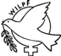
PeaceWomen Library:
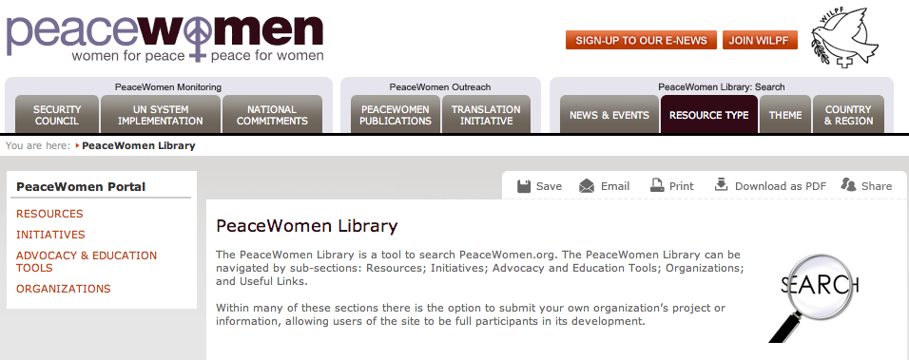

Resources: includes a wide variety of resources from civil society, academic institutions, governments, including Intergovernmental Organizations (IGOs), and UN System entities.

Initiatives: includes actions being carried out or called for at local, national, regional and international levels, such as letter-writing campaigns, petitions, demonstrations, conferences, research, etc.

Advocacy & Education Tools: tools from Civil Society, Academics, Governments and the UN Bodies. These tools provide individuals in the field with cutting edge advocacy messages and strategies aimed at the full implementation of SCR 1325 and its follow-up resolutions.

Organizations lists organizations working on a local, national, regional or international level in the field of women, peace and security.

Search by Type
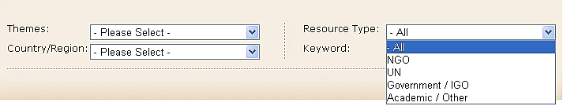 … by Country/Region
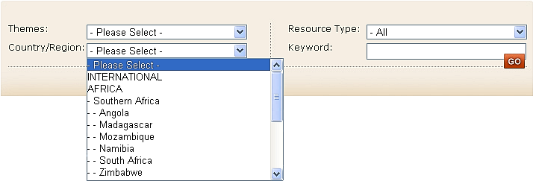
… by Theme
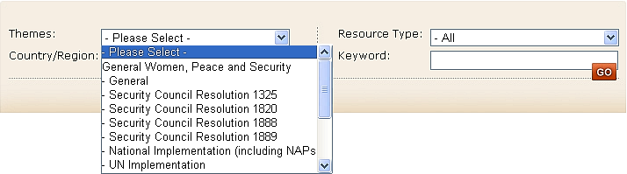
… or by entering your own Keyword
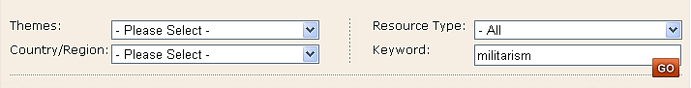
News & Events:
The PeaceWomen Project aims to highlight news and events related to women, peace ands security taking place on local, national, regional and international levels. The News Library and Events Calendar can be navigated by themes, country/region, date and/or keyword. Within both sections, there is the option to submit your own news items and upcoming events.

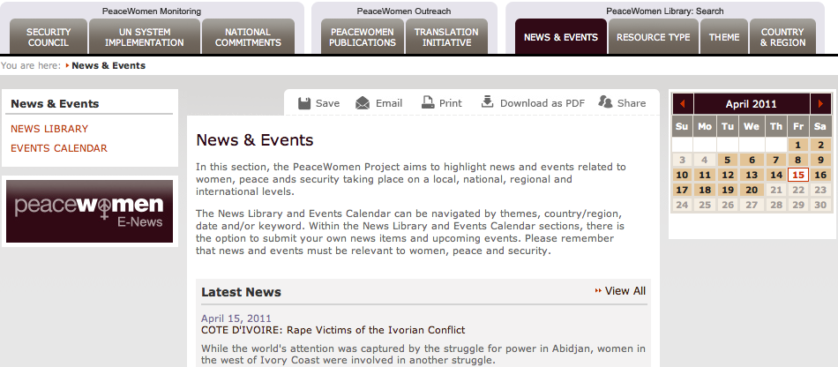

News Library (left)
Search by Theme, Country/Region, Date, Keyword
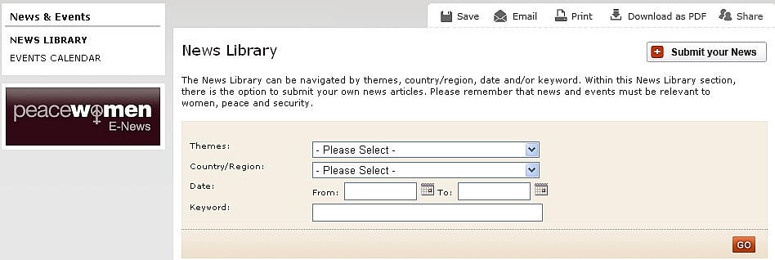

Events Calendar
Upcoming, Archive
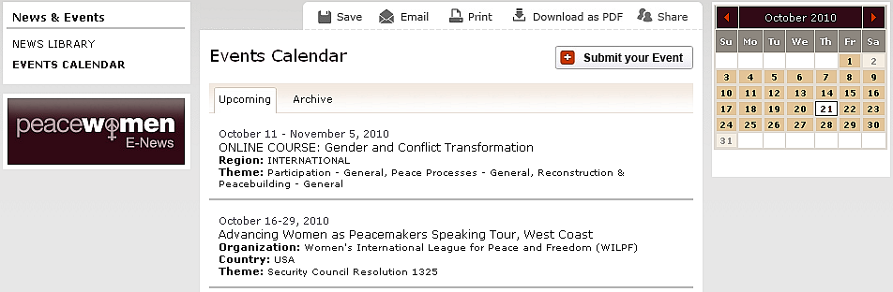

Calendar (right)
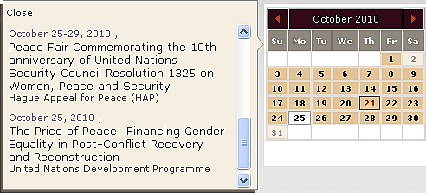
Themes:
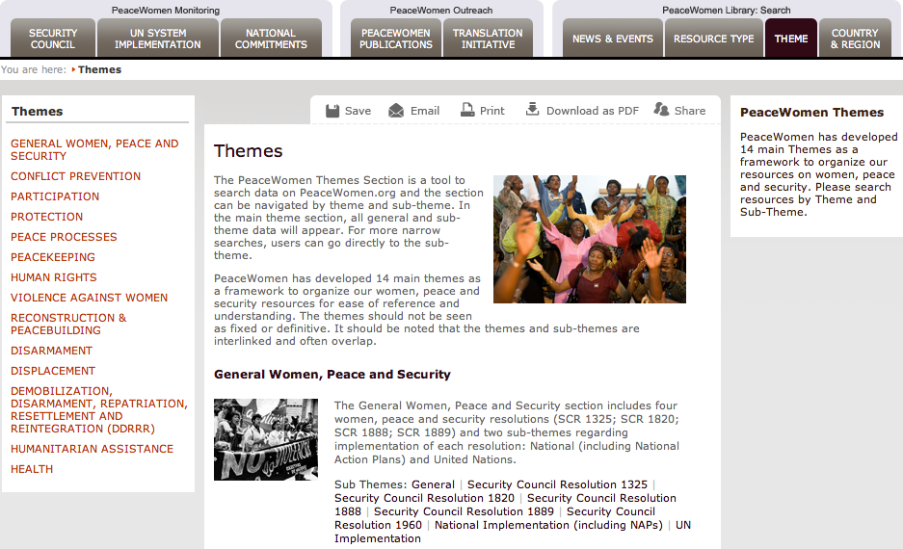
General Women, Peace and Security: General | SCR 1325 | 1820 | 1888 | 1889 | National Implementation (+ NAPs) | UN Implementation

Conflict Prevention: General | Early warning

Participation: General | Peace-Processes | Political Participation |UN Gender Balance and Leadership

Protection

Peace Processes: General | Representation/Participation | Gender Issues Inclusion | Civil Society Activities/Women Organizing for Peace

Peacekeeping: General | Sexual Exploitation & Abuse | Gender Training

Human Rights: General | Socio-Economic rights/Development |Racial & Ethnic discrimination | Intl & Regional Instruments & Mechanisms

Violence Against Women

Reconstruction & Peacebuilding: General | Transitional Justice | Governance and Elections | Security Sector Reform | Human Security & MDGs |Legal Reform, Access to Justice & Constitutions

Disarmament: General | Small Arms & Light Weapons | Landmines

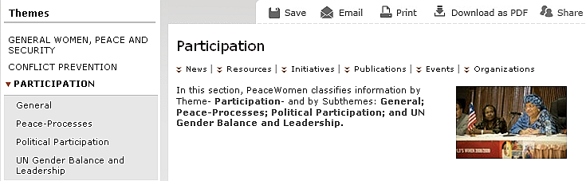

Country/Region:
find News|Resources|Initiatives, etc + 1325 Translations, Organizations
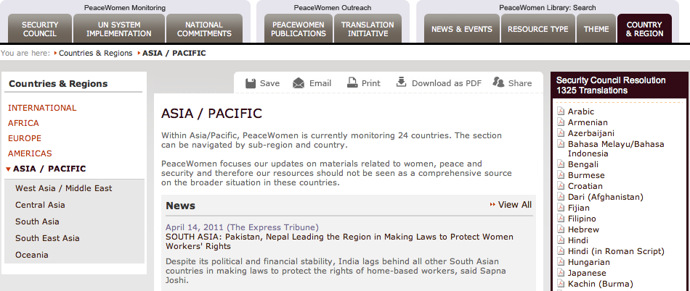

Monitoring:
PeaceWomen & the UN:
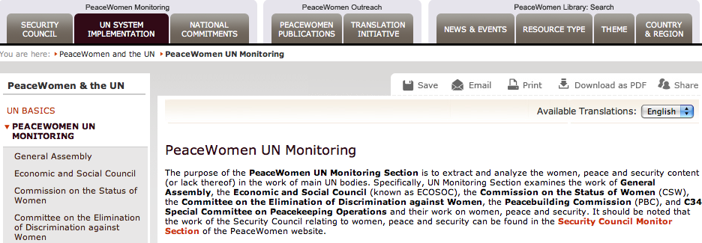

Security Council Monitor:
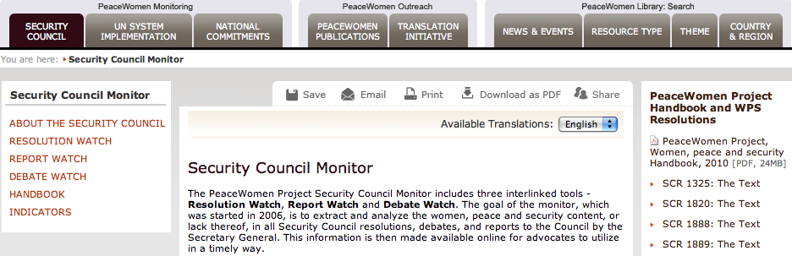

Commitments Database:
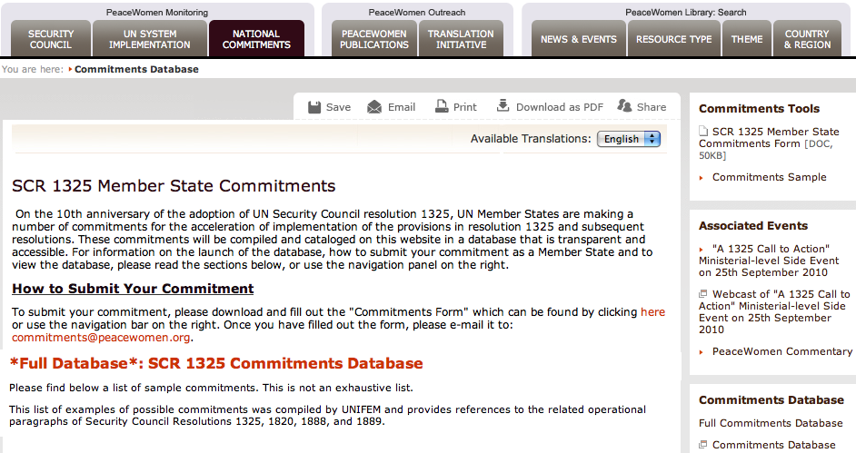

PeaceWomen Publications:
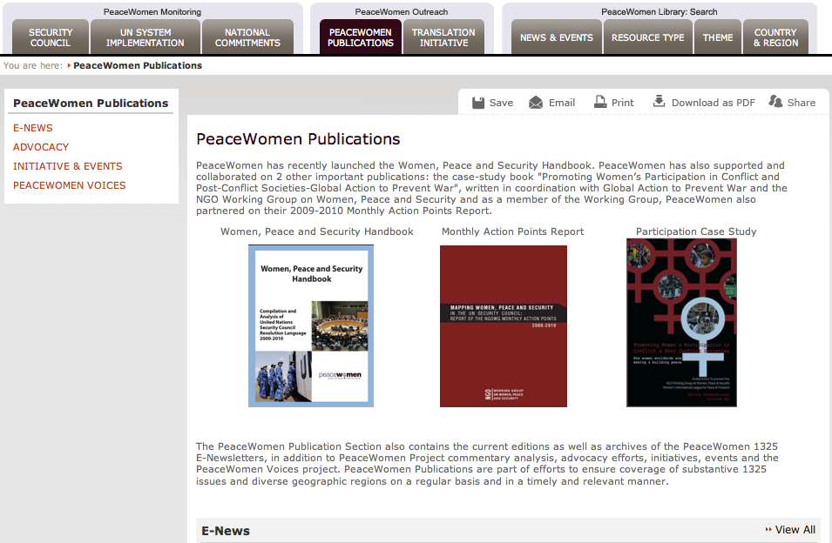
About 1325 and WPS:
find background information and texts of the resolutions

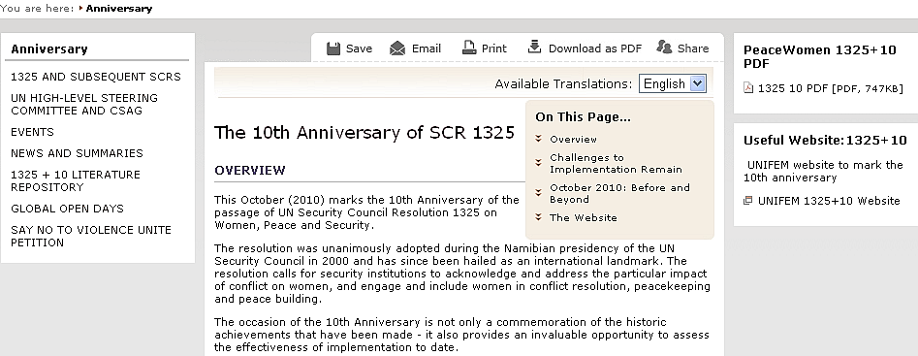

Translation Initiative:
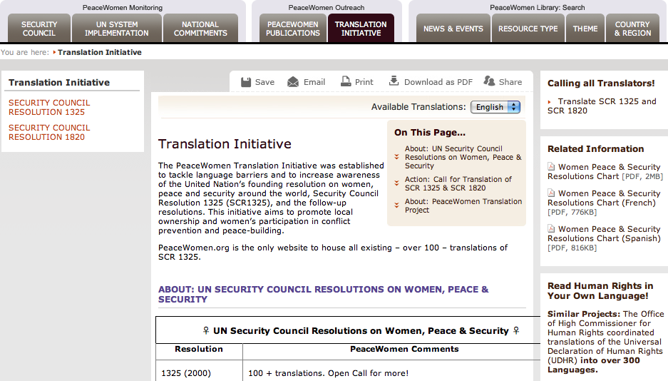

My PeaceWomen:
