
Perspectives from WILPF Nepal
Written by -Nirmala Sitoula
2013

Nepal is small country situated between the large country China and India. Its population is 26.5 million according to recent records. Within the total population, 48.5% are male and 51.5% are female. Nepal is multi cultural, multi ethnic, multi religion, multi language and a multi biodiversity country. There are 125 caste/ethnic groups of people and 118 languages.

The political instability in the country is creating a challenge in our continued efforts to overcome discrimination and social exclusion on the basis of gender, caste, class, ethnic group, disability or geographic situation, in order to ensure the respect of civil, political, economic, social and cultural rights.

In our country, rising prices, corruption, rape, genocide, abduction, impunity, and insecurity is widespread. Dissolution of the constitutional assembly without being able to adopt a new constitution for the country was a blow to Nepal's transition to peace and security.
Transitional justice is an integral part of the peace process, but was overshadowed by negotiations over power sharing and constitutional issues.

A decade of armed conﬂict in Nepal is also thought to have contributed to GBV against women and girls, in particular through rape, trafficking, sexual slavery, displacement, and economic hardship. The abuse of women in armed conﬂict is rooted in a culture of discrimination that denies women equal status to men. Social, political, and religious norms identify women as the property of men, conﬂate women’s chastity with family honor, and legitimize violence against women. Women’s ﬁnancial dependence, subordinate social status, and a lack of legal support render them signiﬁcantly vulnerable to continued abuse. Full implementation of its National Plan of Action for human rights and its plans of actions to implement various human rights conventions and treaties is necessary.

Violence against women cases are increasing day-by-day, particularly crimes of rape. Girls particularly are victims of rape. With reported cases of rapes by fathers, grandfathers, uncles, and neighbors, there is no secure place for women and girls. Sita Rai was looted and raped by public officials at the airport. It is a sad fact that in the cases of violence against women, the victims themselves become the target for blame simply for the fact that she is a girl and therefore must be guilty.

Patriarchy begins within the family. As a result violence against women can be addressed primarily in our own homes and communities by raising awareness on gender equality. To address gender equality within the family, efforts must be made to create an environment of equal access and opportunities for the male and female family members to education, healthcare, and finances. In addition, men must commits to end violence against women within their own home.

There are laws, policies, commitments and directives from the government against trafficking, dowry, domestic violence etc…however the challenge lies with implementing them. Introducing comprehensive legislation and more stringent enforcement of existing laws in the areas of rape, dowry, witchcraft, domestic violence towards women and human trafficking, is necessary and should be in line with international obligations.

Prolonged political transition and impunity is the main reason behind the increasing cases of violence against women in the country. The legal obstacles of implementing these laws, the lack of effective investigation, political intervention, and lengthy legal processes are the main challenges in guaranteeing justice to the victims and holding perpetrators accountable. In these cases specifically, rural women and girls are the most vulnerable to violence.
Many other VAW cases are hiding with suppression. Some are being forced to silence themselves because of “shame” or “fear” of society while other can't speak up because of poverty and economic dependency on men.
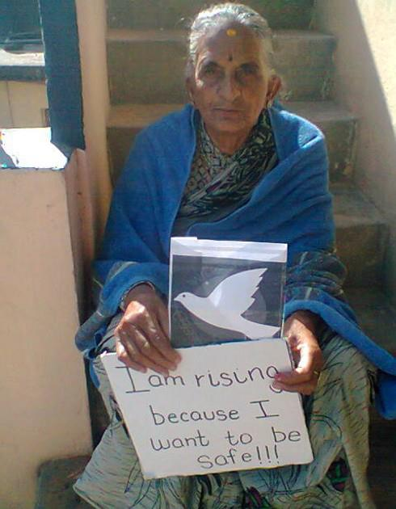
Being a woman, it is always daunting to walk down the street because there might be a group of men down the corner that make it impossible to pass through. After these incidents, women’s voices are muted due to the terror of these men committing their crimes again out in the open. Women's silence has not been broken because of lack of support and security.

Nepal has made strong national and international legal commitments to ending gender based violence and inequality but has failed to implement it.
The social and cultural value of male superiority and female inferiority are of a patriarchal feudal mindset and is our largest hurdle in ensuring gender equality. Nepalese legal system is not victims' friendly and therefore it is largely ineffective.

As crimes of violence against women are rising, fast track court is needed to ensure timely justice.

The 10-year armed conflict from 1992-2006 deeply affected the country. Women and girls still bear the brunt of the armed conflict. Many have been victims of gender-based violence. The government of Nepal is committed to the implementation of the UNSCR 1325 and 1820 as a mechanism for strengthening women’s participation and involvement in the promotion of peace and security within the context of conflict prevention and resolution. In Nepal’s context specifically, these resolutions have great significance. It is with this realization, that the government of Nepal prepared this National Action Plan:

Regarding the right to food and housing in Nepal, Nepali Women have been facing many types of violence. The root cause of this problem is that they are far from right to food and adequate housing. No matter how hard they work, all the resources are under the control of men and thus are dependent on men. As a result, when violence-affected women file a case, they won't have housing and food options when they return. Due to social evils such as Chhaupadi, women have to live in the cowshed during the menstruation period and are unsecured and unhealthy food. They are still fighting and raising voices for the property rights and citizenship rights.

In Nepal, the main reason violence against women occurs is the patriarchal and feudal mindset. Though there are de-jure laws but no access in De-facto laws.

It is necessity not to suppress the courage of our girls/women by restricting their mobility but to educate them on personal safety and gender inequality. Opening discussing and teaching children how to protect themselves from potential abuse at home is necessary. Advocacy and awareness programmes are needed in the following areas.

The lack of state accountability and the failure to bring perpetrators to justice to end this from of violence is the problem.

The gender-based violence is interlinked with the social, political, cultural and religious norms, which perpetuate male superiority and female inferiority.

To challenge the above issues I recommend the following:

- Advocacy programmes to develop laws that are victim friendly
- Interaction programmes on why policy administration is slow in investigations of violence against women. Why are these cases ignored?
- Public hearings and integration programmes to re-commitment state mechanisms and political party leaders
- Awareness programmes to end conservative cultural practices
- Human rights and legal right education
- Immediate response to violence against women cases

