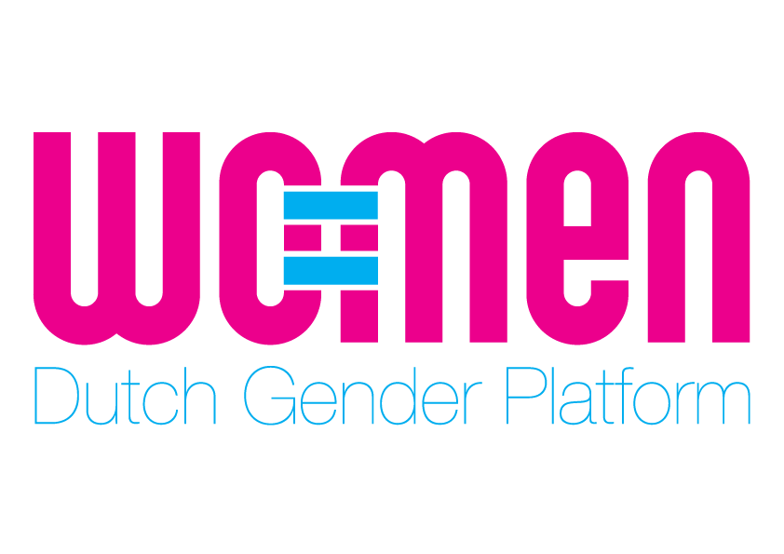

2015 The Netherlands - Civil Society input
Global Study on Women Peace & Security
This paper has been drafted on the basis of the following sources:
- Civil society input during the international 1325 expert conference held on 16th and 17th February 2015 in Amsterdam.
- The Netherlands Civil Society Monitoring report Global Network Women Peace builders 2014.

To achieve effective results on WPS, the international community must address and take action on the following critical areas:
- Participation
- Protection and Promotion of the Rights of Women in Conflict
- Conflict Prevention
- Peacekeeping & security forces
- Financing
- Civil Society Participation
- National Action Plans

Overall
It has been 15 years after the adoption of UNSCR 1325. Besides this first resolution, 6 successive UN Security Council (UNSC) resolutions followed. Today the WPS agenda should move beyond ‘being the most advocated but the least implemented’ set of resolutions. There is a great need to accelerate implementation. This WPS Agenda should be reaffirmed and applied effectively by all Member States, both to prevent conflicts and in all current conflict situations. Over the past 15 years a comprehensive normative framework has led the foundation of the WPS agenda, now the challenge lies at the implementation level: in walking the talk and in sustaining and improving progress made to date.
Member States, the United Nations and other international bodies are called upon to:
- Review their policies and (national) action plans on WPS and strengthen them with the outcomes and recommendations of the Global Study on WPS and hence to develop – together with civil society - a 5 years (2015-2020) actionable and budgeted roadmap to accelerate implementation. Set monitoring mechanism to measure its time-bound implementation.
- Reinforce, apply and monitor the implementation of the UN indicators on Women, Peace and Security (2010)
- Effectively implement CEDAW Recommendation 30 to ensure that governments are held accountable for their UNSCR WPS implementation. Provide political space and support for civil society monitoring and shadow reporting.
Only a transformative approach to the Women, Peace & Security agenda will lead to effective implementation of the resolutions, to effective prevention of conflict and to sustainable change in (post) conflict settings. A transformative approach to the WPS agenda requires:
- Increased attention for the following underdeveloped peace and security elements: conflict prevention, disarmament, non-violence and human security. It is crucial to consider the nexus between peace, security and development.
- Increased attention for underlying gender power relations especially in fragile states and (post) conflict settings that hampers women and girls from being safe and being involved in decision-making processes. Peace and security needs to be redefined from a holistic gender perspective including a masculinities perspective that uncovers the gendered roots of militarism and armed conflict. Analysis of the gendered roots of armed conflict should inform steps towards a long-term goal of taking a preventive, rather than reactive, approach to conflict.
- Promote gender equality and invest in women’s human rights, economic empowerment and continue support to women’s access to basic services (education including literacy, healthcare etc.).
- Increased attention for intersectionality such as class, culture, background etc. it is crucial to keep in mind that women play a variety of rules. Varying from victims to perpetrators and everything in between. It also allows us to see how in some situations some men may be more vulnerable than some women, for example.

- Participation
To regain the transformative intent behind the WPS resolutions. National governments, the UNSC and donor governments need to step up their political and financial efforts to accelerate progress and realize meaningful participation by women and girls, especially from the grassroots, in decision-making processes at all levels.

Member States, the United Nations and other international bodies are called upon to:
- Establish a joint task force, representing government and civil society, to elaborate strategies to ensure meaningful participation of women at all decision making levels. Measures to ensure meaningful participation do not need to be defined top-down. Instead, they should be informed by existing mechanisms that are already used by civil society at grassroots levels, building on successful examples of women’s participation and leadership in community and regional settings.
- Provide political and financial support to women’s peace initiatives, and in particular to protect women leaders – especially in conflict affected countries – to be able to fully participate in a safe environment in decision making processes on peace and security. It is important that financial means are accessible to women’s civil society, e.g.. by ensuring that grant application criteria are gender-sensitive.
- Support through financial, technical and political means all efforts, including concrete incentives, to ensure women and gender experts are included in negotiating parties’ delegations in peace and ceasefire negotiations and in any agreements that may result, as well as include the consideration of the differentiated impact of the conflict on women, girls, men and boys.

- Protection and Promotion of the Rights of Women in Conflict
Women’s leadership and their active participation are pivotal to bottom-up sustainable implementation of the WPS agenda. But their effective participation is not guaranteed if underlying barriers, such as: unequal power relations resulting in persisting conservative and discriminatory mindsets; financial resources; support networks, are not addressed. But in many cases also the physical security of women human rights defenders and activists is in danger and leads to extreme forms of repression, violence or even assassination.

Member States, the United Nations and other international bodies are called upon to:

- Provide political and financial support to protect women human rights defenders, especially in conflict affected countries. Specific interventions should ensure the safety of women leaders and activists in order for them to continue their work.
- Address the shrinking of civil society space worldwide, which is partially driven by states (ab)using a security and CTM agenda to silence critical voices, and particularly highlight its gendered impact.
- Facilitate access to justice for women to legislative bodies, to ensure equal rights for men and women before law and challenge impunity and injustice.
- Create attention for measures that are silencing critical (women’s) voices varying from the abuse of counter terrorism mechanisms to financial or physical persecution.

- Conflict prevention
Only absolute prioritization of conflict prevention and resolution, peace education, education for non-violence, tolerance, acceptance, mutual respect, intercultural and interfaith dialogue and reconciliation and active non-violence can lead to sustainable change to WPS implementation.
Member States, the United Nations and other international bodies are called upon to:
- Prioritize, and actively move towards, a preventive approach to armed conflict at all local, national and international levels of decision-making bodies.
- Actively build upon, and make use of, civil society expertise on conflict prevention. This will help avoid political decisions which may end up fuelling conflict and will instead support civil society efforts including appropriate preventive measures in specific local and regional contexts.
- Include women, men, youth, religious leaders and the media in gender responsive conflict preventions measures that tackle notions of masculinity/femininity and conflict.
- Invest in awareness-raising strategies approaching men with alternative approaches to address conflict (such as active nonviolence and de-escalation techniques).

- Peacekeeping & security forces
While more and more security forces and organizations have gender and WPS policies in place, structural implementation is lacking. It has been proven that the inclusion of gender improves the operational effectiveness and quality. This has to be actively promoted. Moreover, implementation often relies on the will of individual staff members within the governments to include UNSCR WPS and gender perspectives in practice. Participation and meaningful contribution of women in these forces are of great importance, but also the foundation of the security concept that is being pursued by these forces. Security forces should not only be focused on state security but also on gendered human security aimed at securing the diverse security needs of both men, women, boys and girls. An inclusive approach to security is required as security is everybody’s business and responsibility.
Member States, the United Nations and other international bodies are called upon to:
- Hold senior and management-level leaders of security forces accountable and ensure effective monitoring mechanisms for the active and qualitative UNSCR WPS incorporation and a gender perspective into policies and implementation, including through clear instruction to all staff members.
- Incorporate gender perspective, WPS and Protection of Civilians into all recruitment and retention (for example in job descriptions, evaluations and performance assessments), education, training and exercises policies and practices of security forces.
- Build the capacity of local grassroots civil society and women’s organizations on advocacy vis-à-vis the security sector. And facilitate dialogue between (local) women’s organizations, security sector actors, religious leaders and local leaders for an inclusive process.
- Develop and implement an effective human security strategy as this transforms the citizen-state relationship. Effective human security strategies increase state responsiveness and accountability while also increasing trust in the state and empowerment for citizens to participant in governance. Policies should simultaneously empower citizens and improve the state’s effectiveness at protecting them.

- Financing
Lack of sufficient, structural and appropriate funding seriously hampers effective WPS implementation around the world. Security and Defense expenditures require gender-responsive budgeting. Furthermore, a Global Acceleration Instrument (GAI) would urgently and in a time-bound manner (2015-2020) address the challenges to financing for WPS implementation and, in so doing, assist Member States and civil society organizations in overcoming barriers to national implementation.

Member States, the United Nations and other international bodies are called upon to:

- Guarantee earmarked but flexible funding for the implementation of NAPs and Roadmaps and make it part of the national budget.
- Support the Global Acceleration Instrument (GAI) on women, peace and security to be launched in October 2015.
- Ensure that funds made available for women’s empowerment is actually accessible for women’s groups and movements, by gender sensitizing grant criteria.

- Civil society and grass roots participation
Structural and systematic collaboration between governments and international organizations with civil society organizations, specifically grassroots, has proved to be an effective way to progress the WPS agenda, to improve their services to the population as well as to enhance the legitimacy of the authorities and security forces. Also we have experienced that grassroots organizations are the drivers behind the WPS agenda: they have pushed for Resolution 1325 in the first place and they are doing the difficult challenging work on the ground on changing dominant gender power relations and patterns. Despite some improvements in consulting with local civil society, the voices of those affected by the (lack of) implementation of the WPS agenda too often remain unheard.
Member States, the United Nations and other international bodies are called upon to:

- Support local grassroots initiatives structurally over a minimum of 5 years by donor organizations and governments to ensure sustainability.
- Listen to challenges as defined locally, and ensure local ownership of solutions, as they are essential and currently under-implemented practices.

- National Action Plans 1325
Concrete Action Plans and Roadmaps are of utmost importance to ensure acceleration of WPS implementation. Both ministries, as well as civil society, recognize the lacking M&E as a crucial problem. M&E will increase transparency and highlight what the government is achieving, and what it is not. Not only will the M&E benefit the government itself, it will also better enable civil society to perform its watchdog role and allow it to serve as a stronger partner to the governmental ministries in policy strategizing and on projects.
Governments which are developing their NAPs and Roadmaps are called upon to:
- Consult grassroots, women and civil society organizations (including diaspora) and networks in focus countries for the development, implementation and monitoring of the NAPs and Roadmaps.
- Ensure and implement effective monitoring and reporting mechanism for NAPs and Roadmaps. Provide political space and support for civil society monitoring and shadow reporting.
- Involve CSOs from the start in the development, implementation, monitoring, executing and evaluation of peace and security policies, NAPs and Roadmaps while ensuring their independent position.
- Avoid the isolation of Action Plans from core peace and security policies. Align the content of the NAPs, Roadmaps and other WPS strategies with and integrate them into domestic and foreign policy objectives, such as a national security, development and trade strategies, and other relevant policies.
- Ensure domestic policies are reflective of their WPS priorities. Donor governments who have an externally focused NAP need to incorporate a domestic agenda to make sure their domestic and internal policies are also reflecting WPS priorities (such as gender balance in the security sector and immigration and refugee procedures). After all, credibility is key.
- Ensure contextualization and localization of Action Plans in a way it makes sense to a broad audience and it reflects the priorities of the grassroots, civil society and women’s organizations.

